Infrastructure as a service or IaaS
1)IaaS provides users with virtual computing resources, such as virtual machines, storage, and networking.
2)This helps you avoid the expense and complexity of buying and managing your own physical servers and other data centre infrastructure.
3)IaaS is ideal for organizations that need to run legacy applications or need greater control over their infrastructure. Virtual Machines, Virtual Networks, and some Storage Accounts features are infrastructure as a service offered by Azure.

Platform as a service or PaaS
PaaS allows you to avoid the expense and complexity of buying and managing software licenses, the underlying application infrastructure, middleware, container orchestrators or development tools, and other resources. You control the applications and services you develop, and the cloud service provider manages everything else.
PaaS is ideal for organizations that want to quickly develop and deploy new applications without having to worry about the underlying infrastructure. App Service, Azure Functions, and Azure Kubernetes Service are platforms as a service offered by Azure.

Software as a service or SaaS
SaaS is the highest level of service and gives users access to software applications hosted and maintained by Microsoft. With SaaS, users no longer need to worry about managing the underlying infrastructure or developing and deploying applications, the appropriate service agreement, availability and security of the application, and most importantly, your data because Microsoft takes care of it all. SaaS is ideal for organizations that want to use software applications without having to worry about managing them. Office 365, Dynamics 365, and Power BI are a software as a service offered by Azure.

To summarize,
IaaS provides virtual computing resources such as virtual machines, storage, and networking.
PaaS provides a platform for developing and deploying applications.
SaaS provides access to software applications hosted and maintained by Microsoft.

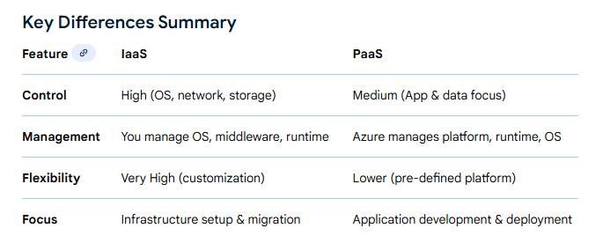

Note:
Paas: Paas is Platform as service is a cloud computing model where you will get all the hardware and software tools that are needed for the development activities.
Saas: Saas is Software as a service that delivers an application as a service via the internet. There is no need to install or maintain the software. You need to access those as a service.

Difference between Azure App service and App service plan:

Azure App Service is the platform-as-a-service (PaaS) that hosts your application (web app, API app, mobile backend, or function app),

an Azure App Service Plan defines the underlying compute resources and features available to that hosted application. An App Service runs within an App Service Plan.

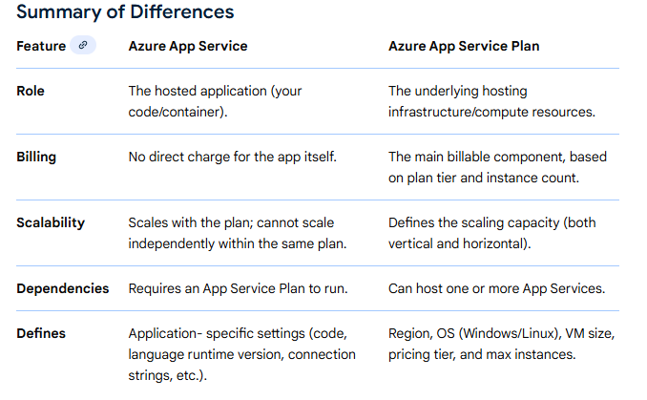

What are the differences between Microsoft Azure and AWS?
